Week 3: Javascripts and PHP basics

3.1 Frontend Interection and Backend Foundations

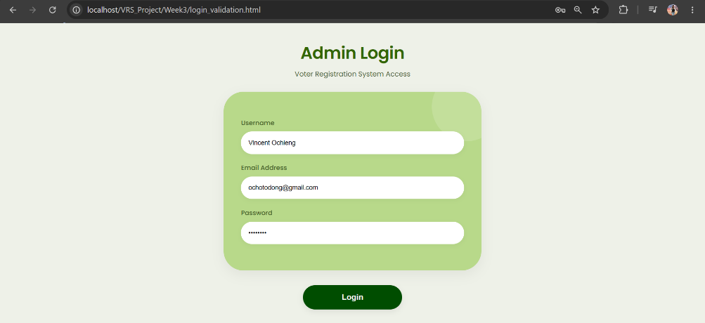
Figure 11: JavaScript Form Validation

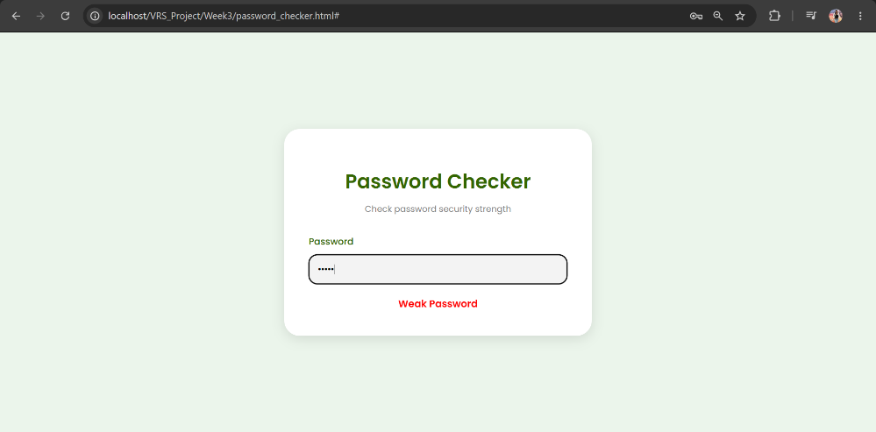
Figure 12: Password Strength Checker
The password I used was 1234 and it was identified as a weak password.
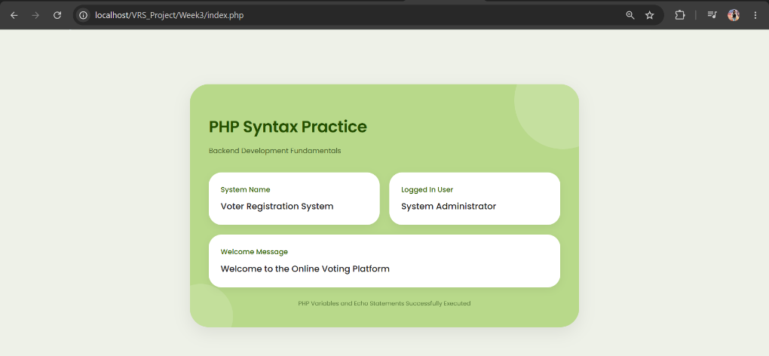
Figure 13: PHP Syntax Practice
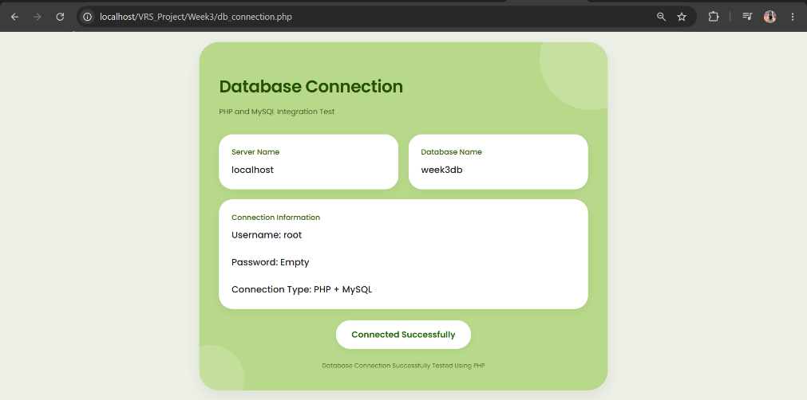
Figure 14: Database Connection Script

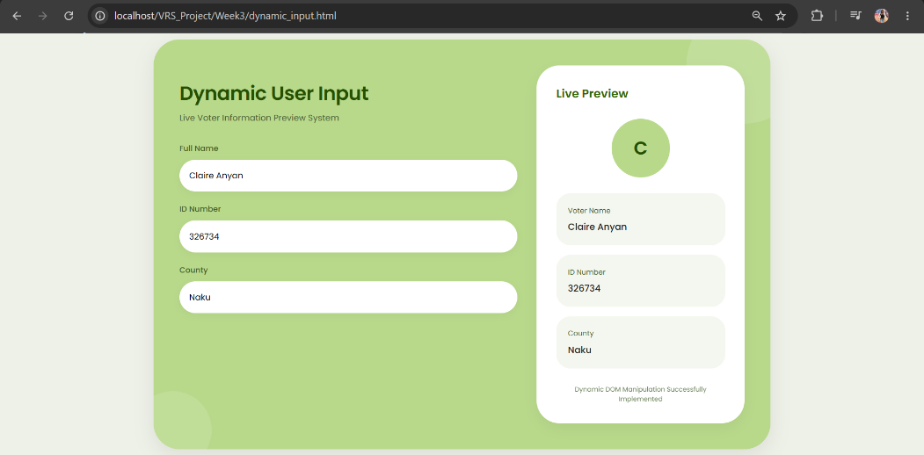
Figure 15: Dynamic User Input Handling

